Neeraj Asthana
nasthan2
4/26/2016
Stat 480 Homework 8

Exercise 1:
Proportions of IMDB rating values:
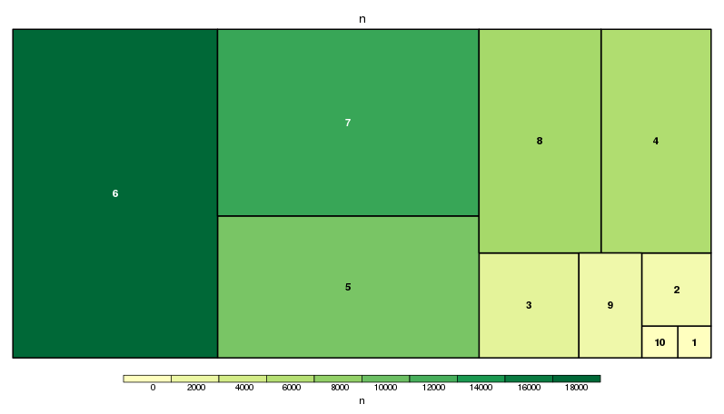
- Most of the movies in newdata have IMDB ratings of 6 and are therefore the most common. There is a very high relative proportion of movies that are rated 6 compared to the other ratings. The next largest rating group is 7. The next highest relative proportions of movies respectively are 5, 8, 4, 3, 9, 2, and 10. Lastly, the least relative proportion of movies have an IMDB rating of 1 and are therefore the least common. Therefore, in general most movies have an IMDB value between 4 and 8 as there is a relatively high proportion of these ratings. In general mot movies do not have an IMDB rating equal to or above a 9 or equal to or below a 3. Therefore, movies tend to not generally be very bad (1,2,3) or extremely good (9,10).

Proportions of MPAA rating values:
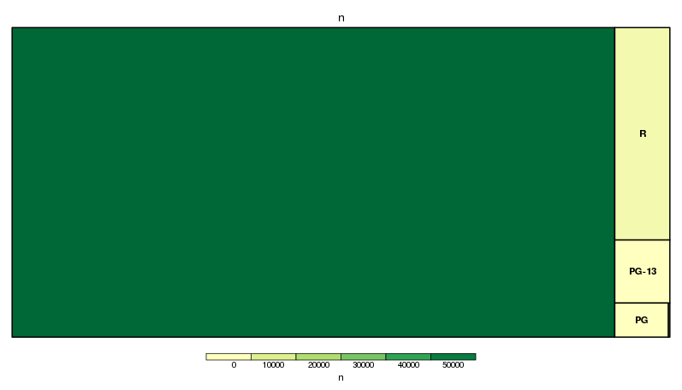
- Most of the movies in newdata have MPAA ratings that are uncategorized and are therefore the most common. There is a very high relative proportion of movies that are uncategorized compared to the other ratings. The next largest group is the “R” rated movies which have a much larger relative proportion that “PG-13”, “PG”, and, “NC-17”. “R” rated movies are followed by “PG-13” movies which are then followed by “PG” rated movies. Lastly, the least relative proportion of movies have an MPAA rating of “NC-17” and are therefore the least common.

Proportion of IMDB ratings within each MPAA rating group:
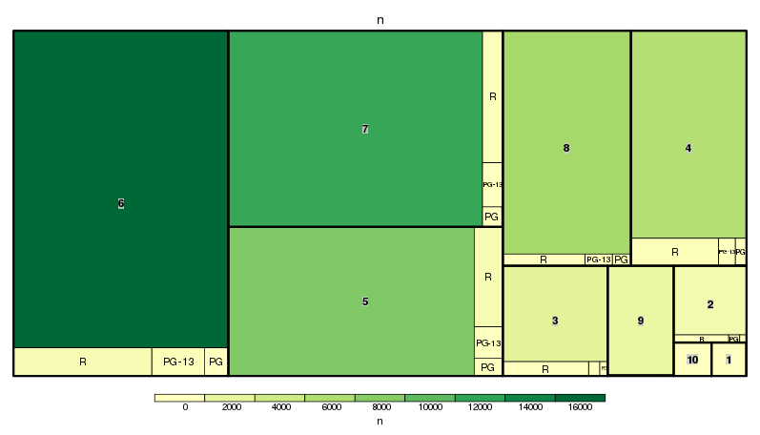

Proportion of MPAA rating group for each IMDB rating value:
